**Anne Aswan Odhiambo**

**Assignment 1**

**Dev Environment Setup**

**Windows 11 installation**

The first thing should be to check if the PC meets the minimum requirements for the installation of windows 11. To do this, I downloaded the PC health check App to check the compatibility.

Then I proceeded to install the windows 11 installation media which allows you to create bootable live USB drives.

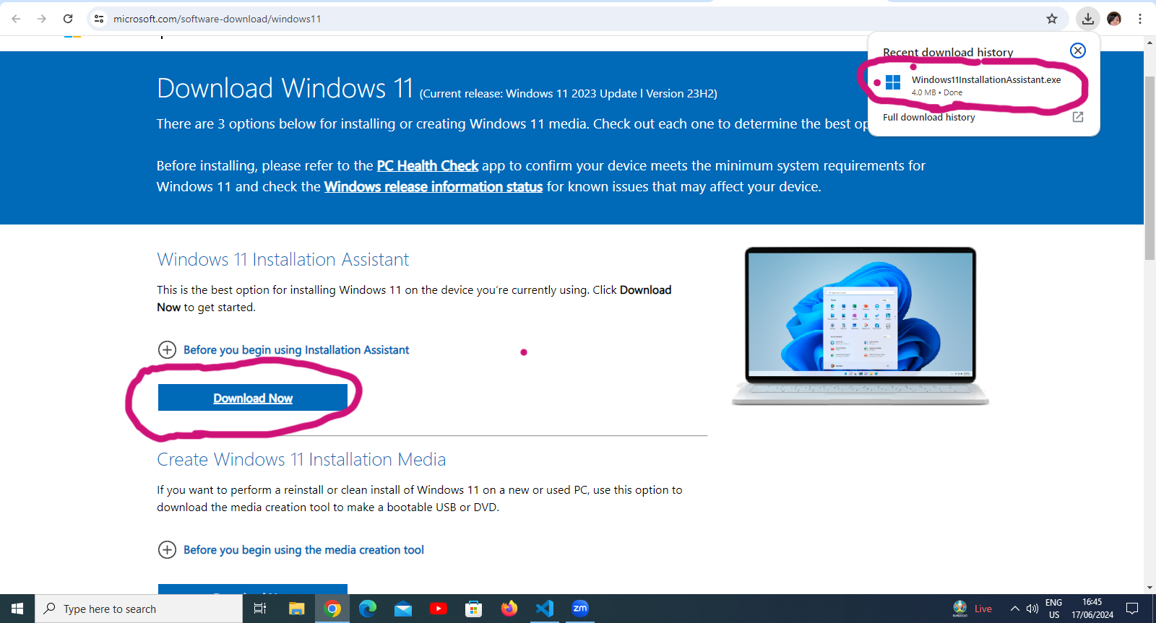

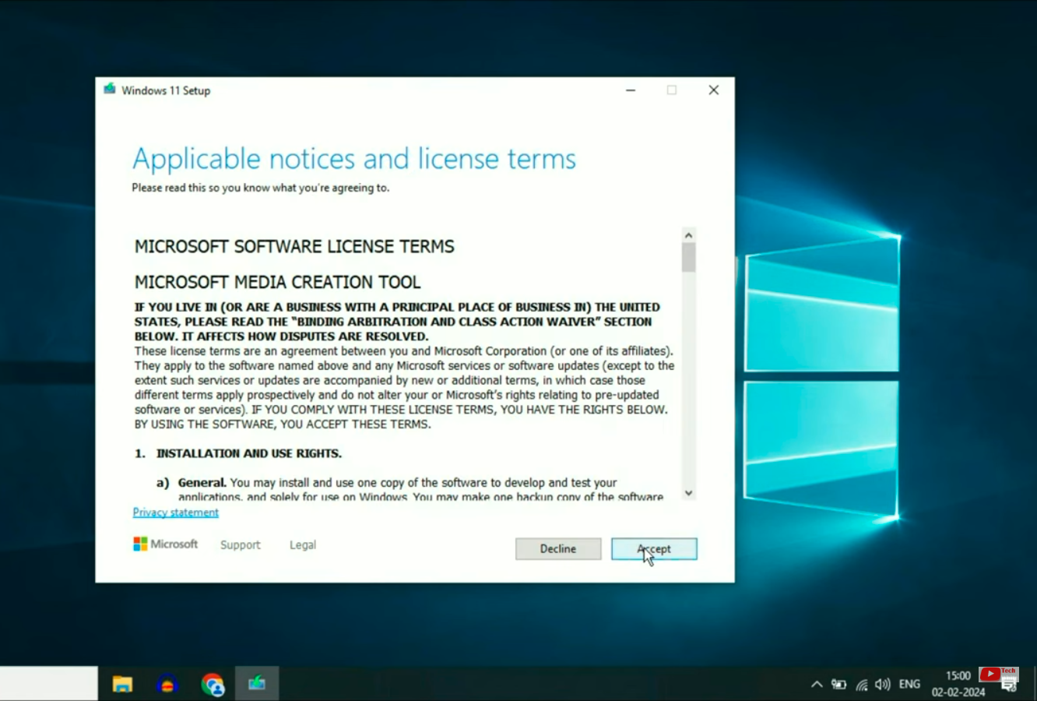

I proceeded with the following steps to successfully download windows 11.

* In the set up wizard, I chose USB drive as the designated wizard
* Connect USB drive
* Format the USB drive
* When the flash drive is ready, remove the drive
* Connect the drive to the destination PC
* Turned on the PC and open the boot-section menu

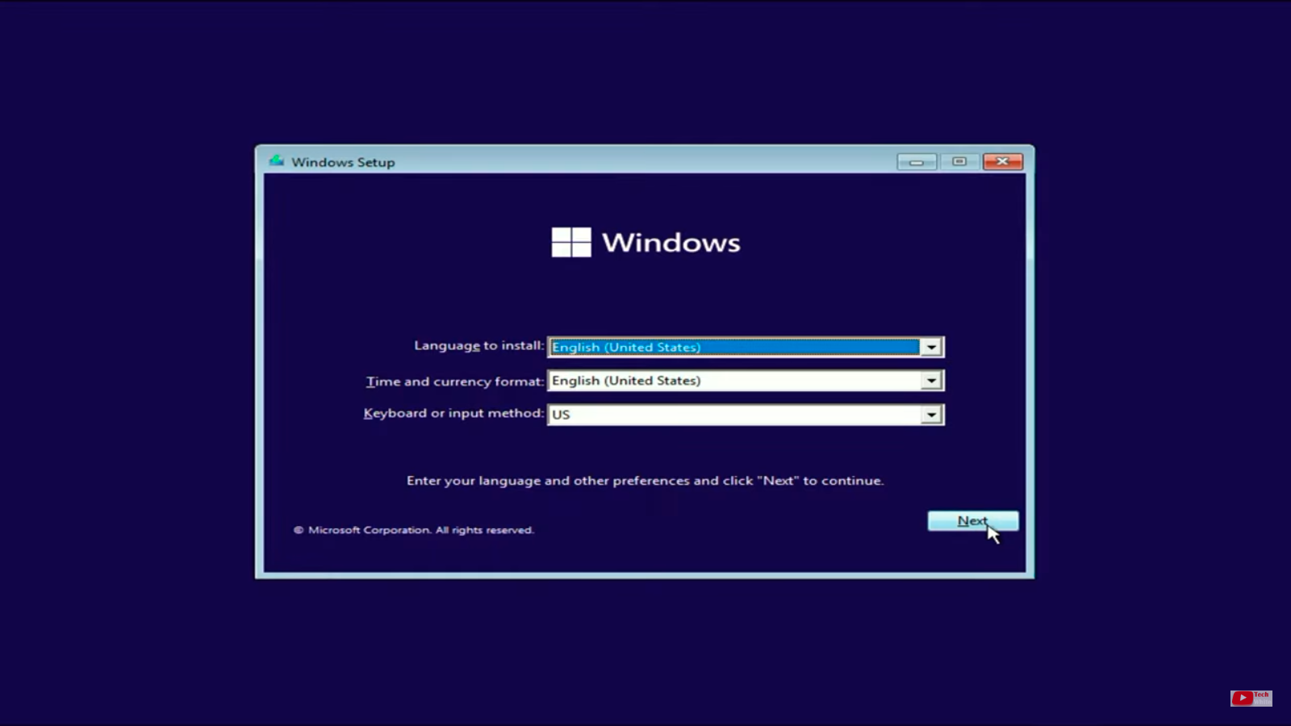

* Windows set-up begins
* Completed the installation process.

**Download and install Visual studio code as (IDE)**

Since I am using windows, I downloaded the Visual studio code for windows. After the download was complete, I opened the setup wizard, and accepted the terms and proceeded to correctly set up the Visual studio code.

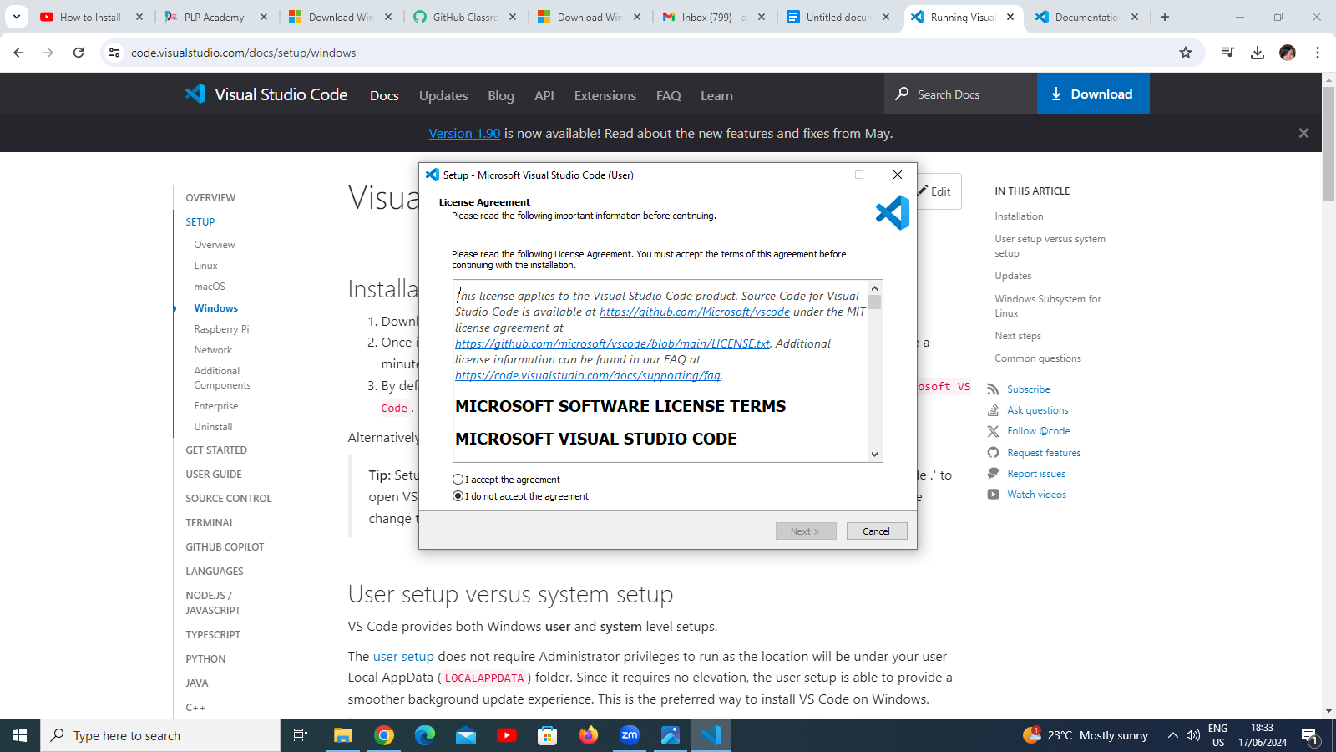

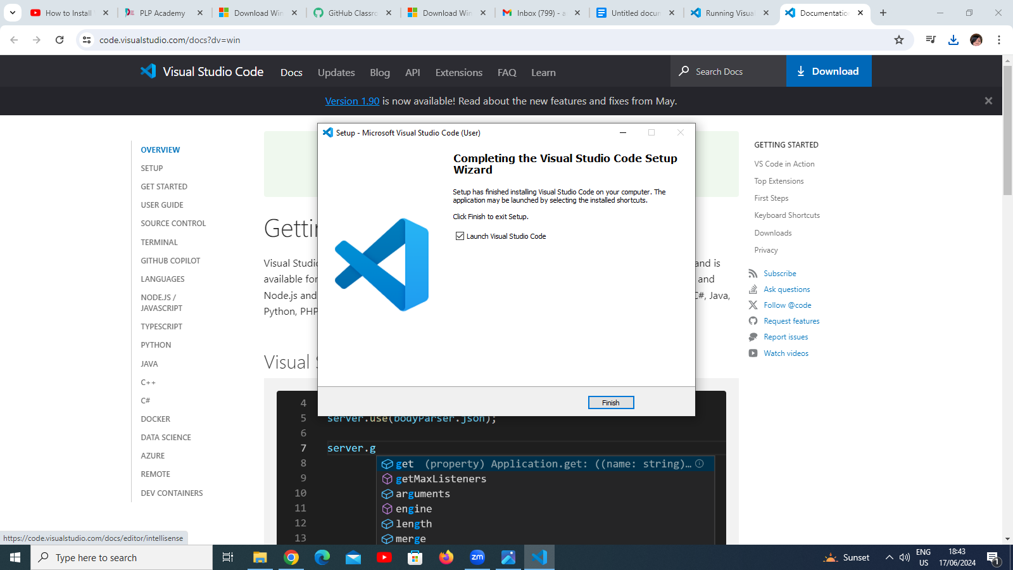

Install Version control systems.

* Navigate to <https://github.com/>.
* Click Sign up.
* Follow the prompts to create a personal account.
* Verify email
* After creating an account you can now create a repository.
* Go to your account, click on your profile, then choose your repositories
* Click on ‘New’

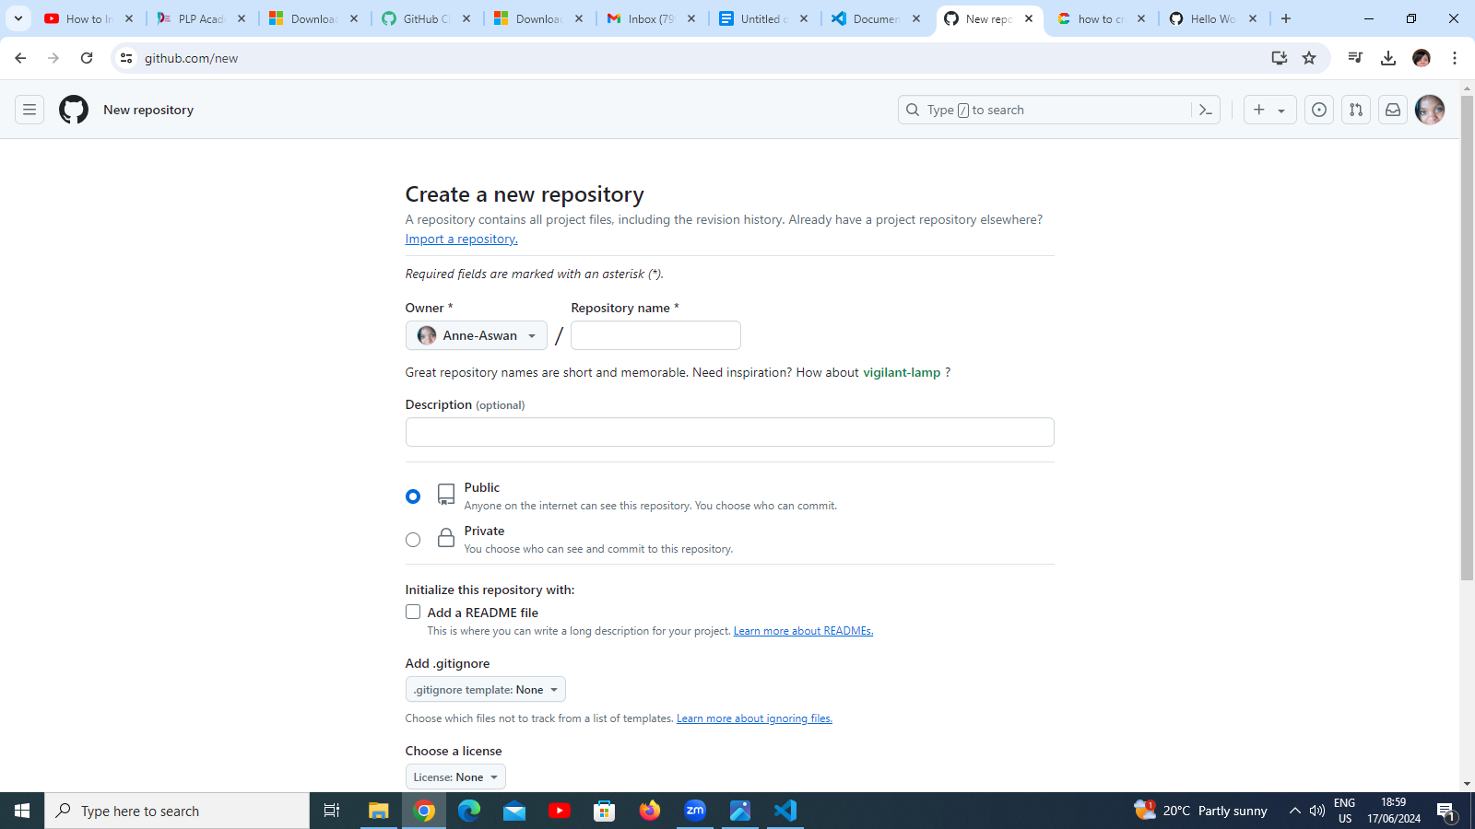

* In the "Repository name" box, the name of the repository.
* In the "Description" box, type a short description.
* Select whether the repository will be Public or Private.
* Select Add a README file.
* Click Create repository.
* To make a commit, click on the README file and click edit
* In the editor, you can write anything then commit the changes
* Edit the commit changes box then click on ‘commit changes’.

**Install necessary programming languages**

Go to Python.org and choose the option for windows and download. Correctly set up the download setup wizard.

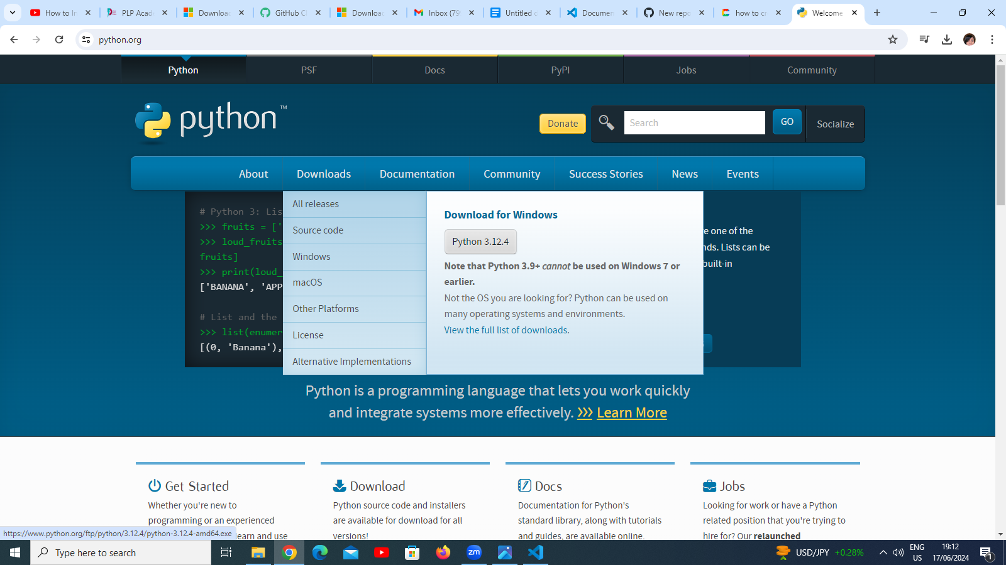

Check all the boxes with features like PIP that come with the Python version and install.

**Configure a database (MYSQL)**

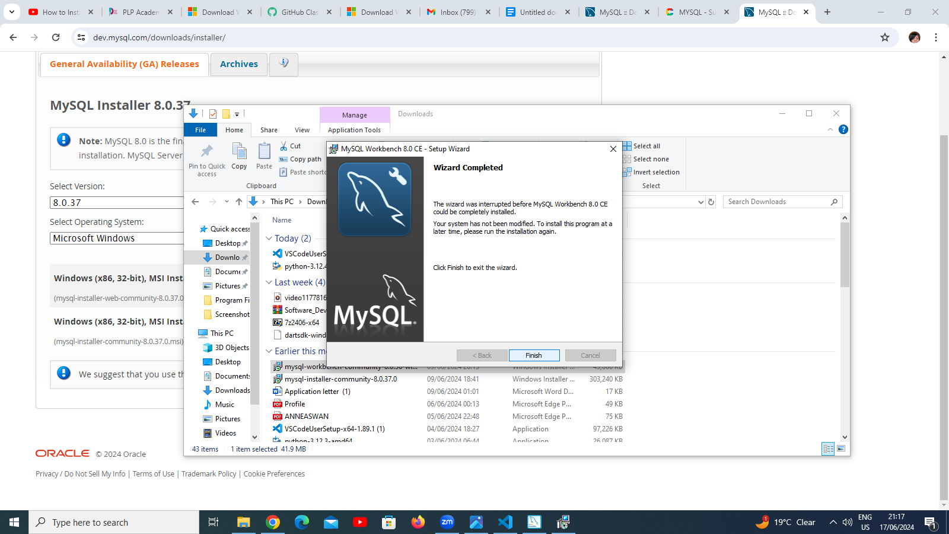

* Visit <https://dev.mysql.com/downloads/installer/>
* Download MySQL for windows
* Finish setting up the wizard ensuring I created a password that I can remember.
* Complete the installation

**Explore extensions and plugins**

I opened my text editor (IDE) visual studio code and clicked on the extensions tab. I installed Prettier code editor,

